 U.S. Consumer Product Safety Commission – Recall

Recall Date: May 26, 2017
Recall Number: 17-168

Cordless Electric Lawn Mowers Recalled Due to Fire Hazard; Made by Hongkong Sun Rise Trading

Recall Summary

Name of Product: Cordless electric lawn mowers

Hazard: The circuit board in the lawn mower can short circuit and catch fire, posing a fire hazard to users.

Remedy: Repair
Consumers should immediately stop using the recalled lawn mowers, remove the battery and contact Hongkong Sun Rise Trading for a free repair.

Consumer Contact: Hongkong Sun Rise Trading toll-free at 888-266-7096 from 9 a.m. to 5 p.m. ET any day or online at www.greenworkstools.com and click on “Important Safety Notice” at the bottom of the page for more information.
Recall Details

Units: About 28,000

Description: This recall involves Kobalt and Greenworks brands of cordless electric walk-behind lawn mowers. The recalled lawn mowers have four wheels (two smaller ones in the front and two larger ones in the back), a 40-volt max lithium ion battery and a deck width of 20 inches. Both models have a large label on the rear bag door area with a serial number, model number and date code. The Kobalt brand mowers also have an item number on the label. “Kobalt” or “Greenworks” is printed on the side of the bag. The following models are included in the recall.

Brand | Product | Colors | Model Number | Item Number | Date Codes
Kobalt | 40-volt max cordless dual-blade push lawn mower | Blue and black | KM2040X-06 | 506586 | 04/14/14 to 05/14/15
Greenworks G-MAX | 40-volt twin force cordless electric push lawn mower | Green and black | 25302 | N/A | 04/10/14 to 07/17/15

Incidents/Injuries: The firm has received 12 reported incidents with the recalled lawn mowers including 5 reports of fires. No injuries have been reported.

Sold at: Lowe’s and other retailers nationwide and online at Amazon.com, Lowes.com and other websites from May 2014 through July 2016 for about $350.

Manufacturer: Hongkong Sun Rise Trading Ltd., of China

Distributor: Sunrise Global Marketing, of Mooresville, N.C.
Manufactured in: China

Photos

Photo 1: Kobalt 40-Volt max dual blade lawn mower
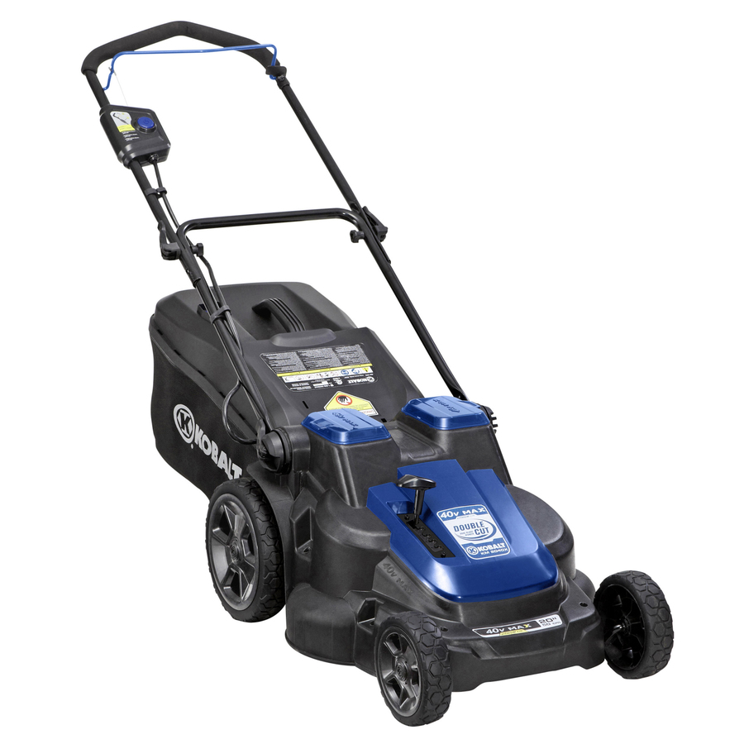

Photo 2: Greenworks G-MAX 40V twin force 20-inch cordless lawn mower
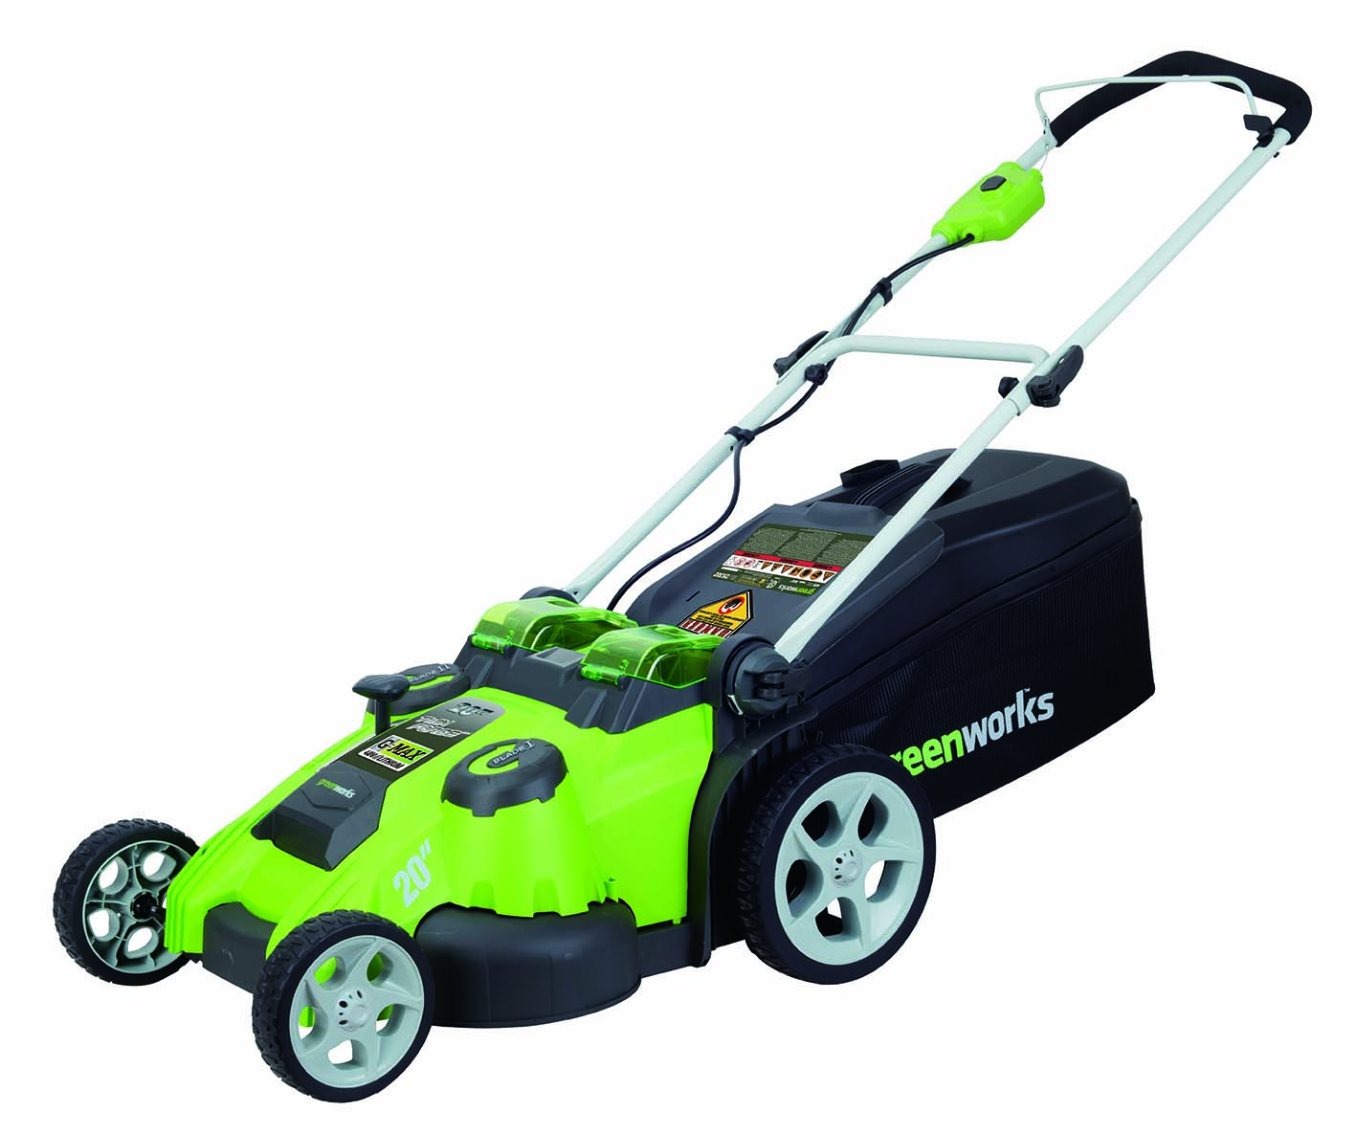

Photo 3: Model number, item number, serial number and date code location on Kobalt lawn mower

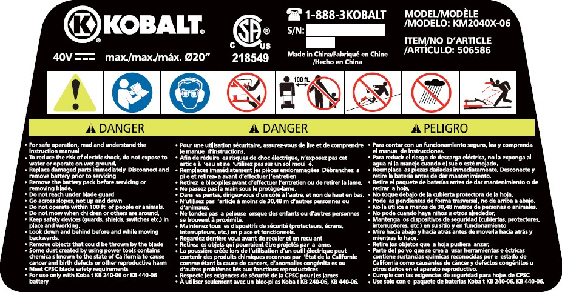

Photo 4: Model number, serial number and date code label on Greenworks lawn mower

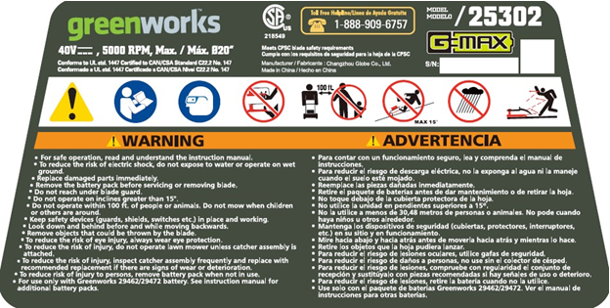

About U.S. CPSC:
The U.S. Consumer Product Safety Commission is charged with protecting the public from unreasonable risks of injury or death associated with the use of thousands of types of consumer products under the agency’s jurisdiction. Deaths, injuries, and property damage from consumer product incidents cost the nation more than $1 trillion annually. CPSC is committed to protecting consumers and families from products that pose a fire, electrical, chemical or mechanical hazard. CPSC’s work to ensure the safety of consumer products - such as toys, cribs, power tools, cigarette lighters and household chemicals – contributed to a decline in the rate of deaths and injuries associated with consumer products over the past 40 years.

Federal law bars any person from selling products subject to a publicly-announced voluntary recall by a manufacturer or a mandatory recall ordered by the Commission.

For more lifesaving information, follow us on Facebook, Instagram @USCPSC and Twitter @USCPSC or sign up to receive our e-mail alerts. To report a dangerous product or a product-related injury go online to www.SaferProducts.gov or call CPSC’s Hotline at 800-638-2772 or teletypewriter at 301-595-7054 for the hearing impaired.

CPSC Consumer Information Hotline
Contact us at this toll-free number if you have questions about a recall:
800-638-2772 (TTY 301-595-7054)
Times: 8 a.m. – 5:30 p.m. ET; Messages can be left anytime
Call to get product safety and other agency information and to report unsafe products.

Media Contact
Please use the phone numbers below for all media requests.
Phone: 301-504-7908
Spanish: 301-504-7800

